Bootstrap Question

CSS question

JavaScript Question

[1,2,3 and 4]

React Question

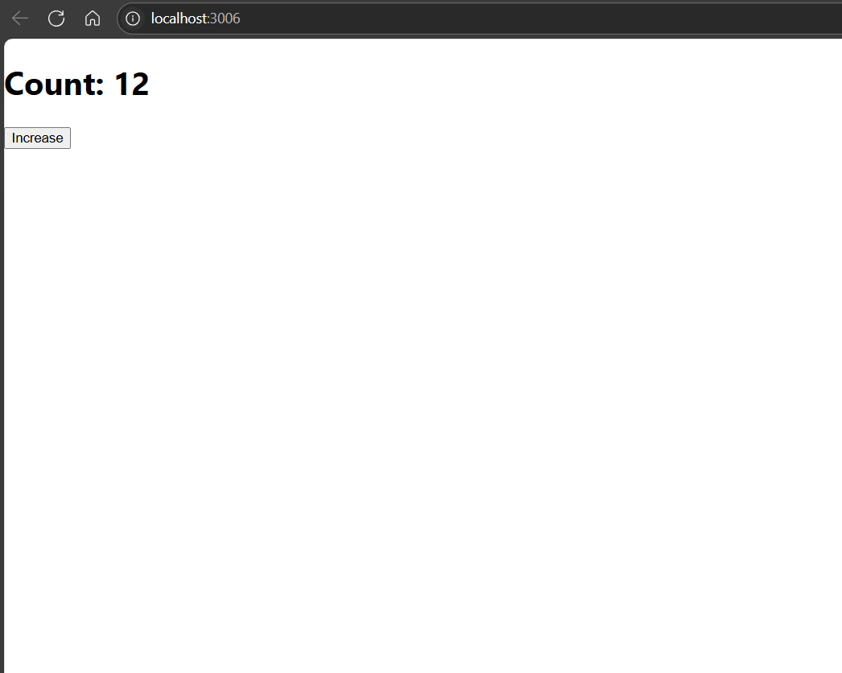1.

2.

5.

6.

7.

12.

11. 